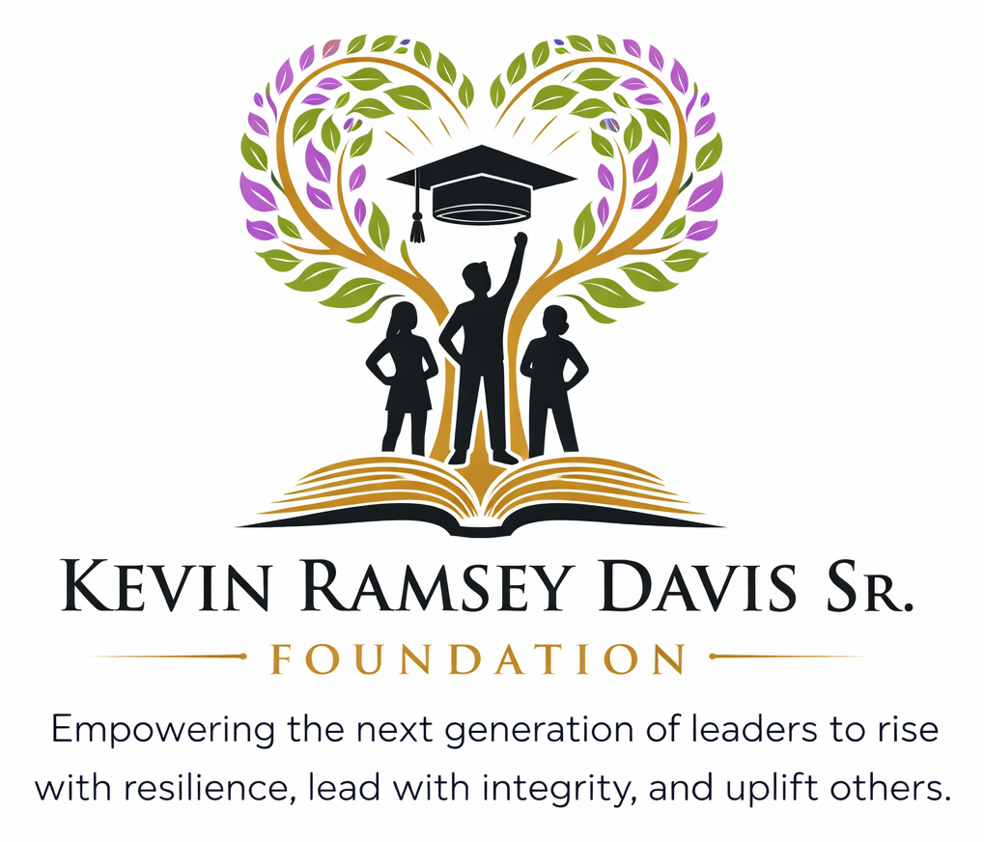
INDIVIDUAL SPONSORSHIP
SPONSORSHIP PACKET
Investing in youth. Strengthening communities. Creating opportunity.

About the Foundation
The Kevin Ramsey Davis Sr. Foundation is committed to empowering young people through meaningful opportunities that strengthen character, encourage academic achievement, cultivate leadership, and inspire service.

Our Mission
Through scholarships, mentorship, and community engagement, we strive to remove barriers to success and inspire young people to reach their full potential. Our mission is to strengthen youth development by promoting character, academic achievement, and service through structured programs, scholarships, and community partnerships.

What We Do
- Provide scholarship opportunities that support educational advancement.
- Create mentorship experiences that connect youth with positive role models and guidance.
- Develop youth programs centered on character, leadership, academic readiness, and personal growth.
- Engage youth and families through community outreach and service initiatives.
- Build partnerships with individuals, families, churches, and community supporters to expand our impact.

Our Commitment
We believe every young person deserves access to encouragement, resources, relationships, and opportunities that help them learn, grow, lead, and succeed.

Why Your Support Matters
At the Kevin Ramsey Davis Sr. Foundation, our sponsors are more than supporters - they are valued partners in our mission to empower youth, strengthen communities, and create opportunities for the next generation.
Sponsorship helps make our work possible. Through the generosity of individual donors, families, friends, and community supporters, we are able to expand our scholarship opportunities, mentorship initiatives, youth programs, community outreach, and volunteer efforts. Every sponsorship is an investment in the young people and communities we serve.
When you become a sponsor of the Kevin Ramsey Davis Sr. Foundation, you join us in creating meaningful experiences, providing valuable resources, and opening doors of opportunity for youth to learn, grow, lead, and succeed.

Partner With Purpose
- Make a personal investment in youth development, education, leadership, and community impact.
- Help expand opportunities for young people through scholarships, mentorship, programs, outreach, and service.
- Create a meaningful legacy of giving that strengthens the next generation.
- Participate in volunteer, mentorship, and community engagement opportunities.
- Receive recognition that reflects your commitment to the Foundation and the youth we serve.

Sponsorship Opportunities
Choose the individual sponsorship level that best reflects the impact you would like to make. Gifts at other amounts are also welcome.
TITLE SPONSOR  $25,000+  • Exclusive recognition as a lead Foundation partner  • Prominent logo placement across applicable Foundation materials and digital platforms  • Featured recognition in campaign communications and social media  • Speaking or recognition opportunity at select Foundation events  • Customized annual impact summary | PREMIER SPONSOR  $10,000  • High-visibility logo recognition on applicable Foundation materials  • Recognition in Foundation communications and social media  • Priority recognition at select Foundation programs and events  • Opportunities for volunteer and community engagement participation
SUPPORTING SPONSOR  $5,000  • Logo/name recognition on applicable Foundation materials and website  • Inclusion in sponsor acknowledgments and campaign communications  • Recognition at select Foundation activities | COMMUNITY PARTNER  $2,500  • Name recognition on applicable Foundation materials  • Acknowledgment in Foundation communications  • Recognition as a community partner

Custom Giving Opportunities
We welcome gifts at any level and are happy to discuss a giving opportunity that reflects your interests and the area of the Foundation’s work you would most like to support.

Individual Sponsorship Application
Please complete the information below so we can acknowledge your support and coordinate any applicable sponsorship benefits.
Individual Sponsor Name  ________________________________ | Affiliation (optional)  ________________________________
Contact Person  ________________________________ | Preferred Contact Method  ________________________________
Email Address  ________________________________ | Phone Number  ________________________________
Mailing Address  ________________________________ | City / State / ZIP  ________________________________
Contribution Amount  ________________________________ | Selected Sponsorship Level  ________________________________

Preferred Recognition Name (or Anonymous): _________________________________________________
Social Media Handle (optional): __________________________________________________________
Additional Notes: ________________________________________________________________
________________________________________________________________________________

Ways to Give & Contact Information

By Check
Payable to: Kevin Ramsey Davis, Sr. Foundation, Inc.
Mail to: 220 1st St., Ocoee, FL 34761

Tax Information
The Kevin Ramsey Davis, Sr. Foundation, Inc. is a 501(c)(3) nonprofit organization. Contributions are tax-deductible to the extent allowed by law.
EIN: 41-3365224

Completed Individual Sponsorship Materials
Please send all completed individual sponsorship applications and supporting documents to the contact information listed below.
ANGELA R. DAVIS, PRESIDENT
Kevin Ramsey Davis, Sr. Foundation, Inc.
407-579-7743
EsqPearl17@gmail.com
Info@thekevinramseydavissrfoundation.org

Thank You for Partnering With Us
Your sponsorship helps create opportunities for young people to build character, pursue academic success, experience mentorship, serve their communities, and reach their full potential.

