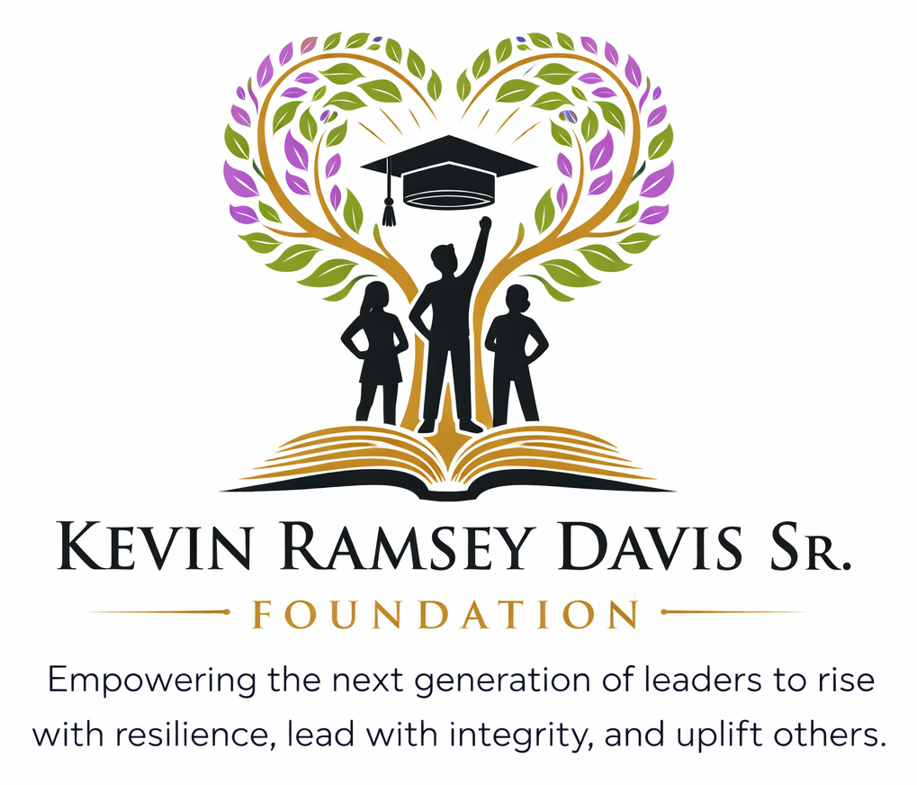
CORPORATE SPONSORSHIP
PARTNERSHIP PACKET
Investing in youth. Strengthening communities. Creating opportunity.

About the Foundation
The Kevin Ramsey Davis Sr. Foundation is committed to empowering young people through meaningful opportunities that strengthen character, encourage academic achievement, cultivate leadership, and inspire service.

Our Mission
Through scholarships, mentorship, and community engagement, we strive to remove barriers to success and inspire young people to reach their full potential. Our mission is to strengthen youth development by promoting character, academic achievement, and service through structured programs, scholarships, and community partnerships.

What We Do
- Provide scholarship opportunities that support educational advancement.
- Create mentorship experiences that connect youth with positive role models and guidance.
- Develop youth programs centered on character, leadership, academic readiness, and personal growth.
- Engage youth and families through community outreach and service initiatives.
- Build partnerships with businesses, organizations, churches, and community leaders to expand our impact.

Our Commitment
We believe every young person deserves access to encouragement, resources, relationships, and opportunities that help them learn, grow, lead, and succeed.

Why Your Support Matters
At the Kevin Ramsey Davis Sr. Foundation, our sponsors are more than supporters - they are valued partners in our mission to empower youth, strengthen communities, and create opportunities for the next generation.
Sponsorship helps make our work possible. Through the generosity of businesses, organizations, community partners, and individuals, we are able to expand our scholarship opportunities, mentorship initiatives, youth programs, community outreach, and volunteer efforts. Every sponsorship is an investment in the young people and communities we serve.
When you become a sponsor of the Kevin Ramsey Davis Sr. Foundation, you join us in creating meaningful experiences, providing valuable resources, and opening doors of opportunity for youth to learn, grow, lead, and succeed.

Partner With Purpose
- Align your organization with youth development, education, leadership, and community impact.
- Demonstrate meaningful corporate and community responsibility.
- Build goodwill and strengthen relationships in the communities you serve.
- Create opportunities for employee engagement, volunteerism, and mentorship.
- Receive recognition that reflects your commitment to investing in the next generation.

Sponsorship Opportunities
Choose the level that best aligns with your organization’s community engagement goals. Customized partnerships are also available.
TITLE SPONSOR  $25,000+  • Exclusive recognition as a lead Foundation partner  • Prominent logo placement across applicable Foundation materials and digital platforms  • Featured recognition in campaign communications and social media  • Speaking or recognition opportunity at select Foundation events  • Customized annual impact summary | PREMIER SPONSOR  $10,000  • High-visibility logo recognition on applicable Foundation materials  • Recognition in Foundation communications and social media  • Priority recognition at select Foundation programs and events  • Opportunities for employee volunteer and engagement participation
SUPPORTING SPONSOR  $5,000  • Logo/name recognition on applicable Foundation materials and website  • Inclusion in sponsor acknowledgments and campaign communications  • Recognition at select Foundation activities | COMMUNITY PARTNER  $2,500  • Name recognition on applicable Foundation materials  • Acknowledgment in Foundation communications  • Recognition as a community partner

Custom Partnerships
We welcome the opportunity to tailor a sponsorship package that aligns with your organization’s philanthropic, employee engagement, and community impact goals.

Sponsorship Application
Please complete the information below. This information will help us acknowledge your support and coordinate partnership benefits.
Sponsor / Donor Name  ________________________________ | Business / Organization  ________________________________
Contact Person  ________________________________ | Title / Role  ________________________________
Email Address  ________________________________ | Phone Number  ________________________________
Mailing Address  ________________________________ | City / State / ZIP  ________________________________
Contribution Amount  ________________________________ | Selected Sponsorship Level  ________________________________

Preferred Recognition Name: ____________________________________________________________
Website / Social Media (optional): ___________________________________________________
Additional Notes: ________________________________________________________________
________________________________________________________________________________

Ways to Give & Contact Information

By Check
Payable to: Kevin Ramsey Davis, Sr. Foundation, Inc.
Mail to: 220 1st St., Ocoee, FL 34761

Tax Information
The Kevin Ramsey Davis, Sr. Foundation, Inc. is a 501(c)(3) nonprofit organization. Contributions are tax-deductible to the extent allowed by law.
EIN: 41-3365224

Completed Sponsorship Materials
Please send all completed sponsorship applications and supporting documents to the contact information listed below.
ANGELA R. DAVIS, PRESIDENT
Kevin Ramsey Davis, Sr. Foundation, Inc.
407-579-7743
EsqPearl17@gmail.com
Info@thekevinramseydavissrfoundation.org

Thank You for Partnering With Us
Your sponsorship helps create opportunities for young people to build character, pursue academic success, experience mentorship, serve their communities, and reach their full potential.

